Fabrikam Residences Case Study (Capstone)
- Recommended Modality: Read through the case study with your learners then have them do the designs individually.
- Link: Fabrikam Residences
This case study is the only comprehensive case study in the course. This case study is not just for Log and Monitor.
This case study gives the learners a chance to put all their learning into a single design. Have your learners do their designs and then share them in the chat. You can talk through the design and focus on the things they have done well. It is a wonderful opportunity to bring all the content together in a single capstone. It is a nice proof to a learner that they can implement what they have learned.

Scenario
You have taken a new position with Fabrikam Residences, which is very successful and is experiencing rapid growth. Fabrikam Residences is a building contractor for new homes and major home renovations and has become successful by providing quality buildings and offering newer integrated home technologies than their competitors.
Currently these technologies are provided and managed by separate subcontract companies. The owners of Fabrikam Residences want to begin offering these upgraded technology options in-house to provide better quality, support and data on customer patterns and needs.
Initially, the company wants to offer HVAC (heating and cooling) control and monitoring, security system monitoring and alerts, and home automation. This will require a new website, data storage solution and data ingestion solution.
The company has seen tremendous growth over the past 2 years. The company is estimating it may double in size over the next 12-18 months. With such rapid growth in the regional market, the company has no current plans to expand outside of the regional market.
The Fabrikam Headquarters runs a small datacenter in a single location. The datacenter hosts the company Project Management (PM) software.
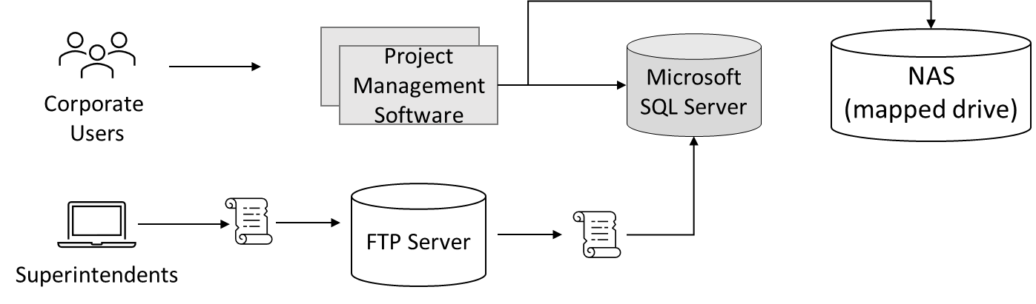
- The PM software uses a third-party Windows application. The application runs on a 2node Network Load Balancing (NLB) cluster with a single Microsoft SQL Server backend.
- Images and documents are stored on a mapped drive of the server, which exists on a dedicated NAS appliance.
- Corporate users, office staff, use a web front end to enter data such as supply delivery schedules and change orders.
- Field superintendents use Windows laptops and tablets offline to continuously record building progress and other details. These changes, such as new work orders, are stored in a local change file. At the end of each day, superintendents return to the office to connect to the wireless network and run a small script to upload the change file to an FTP server. A second script is scheduled to run each night to process all the change files and enter their contents into the Project Management database (Microsoft SQL Server).

Requirements
Project Management software
- Migrate as many of the systems to a public cloud provider as possible.
- Replace the existing scripts to use a system more secure than FTP, as security concerns have arisen. Also, you have been asked to make sure that change files are processed as soon as they are uploaded.
- Increase the resilience of the project management database. While performance is not an issue, the company would like to avoid losing access to the database in case of a single hardware failure.

Tasks
1. Design a solution for the Project Management software. Be prepared to explain why you chose each component of the design and how it meets the solution requirements.

Instructor solution
Project Management Software

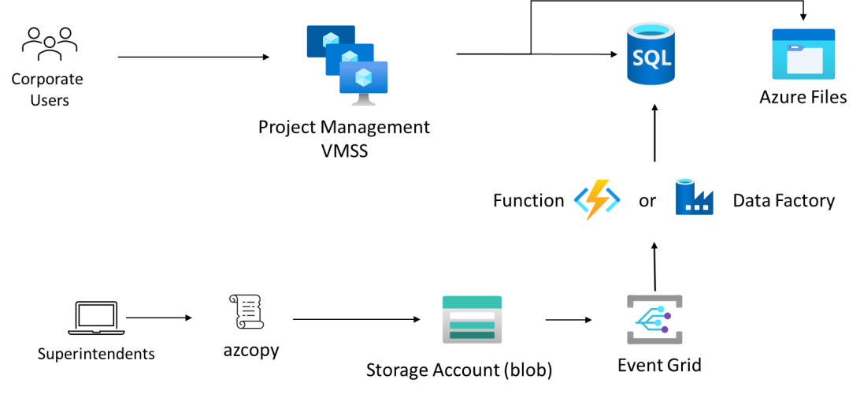
- A VM Scale Set could be used to run the project management software. As the software already runs on an NLB cluster, it is highly likely that it would function correctly on a VMSS. VM Scale Sets would also allow for health probes and self-healing in the even one of the project management servers stopped working. Since the software is provided by a third-party vendor, it would require vendor support to run in an App Service or container. It may be worth contacting the vendor to determine if that is a choice.
- An Azure SQL Database should be the first choice for the project management database. The general tier does provide some redundancies. If more redundancy is required, the database can be upgraded to the Business-Critical tier.
- Azure Files should be used to replace the NAS functionality as it provides SMB (mapped drive) support for the Project Management software
- Blob storage should be used to replace the FTP server. Blob storage provides the features and security necessary at the lowest price point. Azure Files may work but would come at a higher price.
- The script used by the superintendents should be upgraded to use a tool such as AZCopy. AZCopy can directly copy files to the blob storage from the local machines.
- Event Grid can be used to trigger data import immediately after superintendents’ upload change files.
- Azure Data Factory or an Azure Function App could be used to import the change files into the database. Azure Data Factory would provide an easier, no-code path. If the workflow requires more flexibility, an Azure Function could be custom written.
- Consider using Private Endpoints for PaaS services to improve security.

